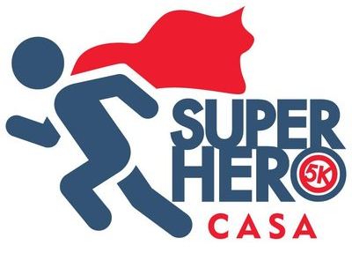
Harrison County CASA
445 W. Main Street
Clarksburg, WV 26301
(304) 623-5749
casa@hcwvcasa.org
CASA of Marion County
112 Adams St, Ste 201
Fairmont, WV 26554
(304) 366-4198
casaofmarion@gmail.com
Sponsorship Form
Sponsor Information:
Company Name*: Contact Name:
Phone: Email:
Address:
Website:
* As you would like your business name to appear on social media.

All sponsorship checks and logos are due by April 10, 2024 to be included on the event shirt.
Check One: | Sponsorship Level | Sponsor Amount | Recognition Plaque | Table/ Tent Setup | Company Banner at Event | Logo on Event Shirt | Logo on Print Items | Logo on Social Media | Promo item in runner bag | # of Race Entries Included
 | Champion | $5,000 | * | * | * | * | * | * | * | 10
 | Superstar | $2,500 |  | * | * | * | * | * | * | 7
 | Hero | $1,000 |  |  | * | * | * | * | * | 4
 | Defender | $500 |  |  |  | * | * | * | * | 2
 | Hydrator  * Limited to 3 | $500 |  |  |  | * | * | * | * | 2
 | Guardian | $250 |  |  |  |  | * | * | * | 1
 | Friend | $100 |  |  |  |  |  | * | * | 1
* The Hydrator sponsorship is for the water stops along the race route, please contact one of the CASA programs listed above for more details and availability.
Sponsor Amount: Date:
Please complete the following:
- Make the check payable to CASA (with Superhero 5K in the memo line)
- Mail check and completed sponsorship form to Harrison County CASA
445 W. Main Street, Clarksburg WV 26301
- Send your company logo to casa5kwv@gmail.com
Please identify if you wish to include promo items in the runner bags Yes: ☐ No: ☐

